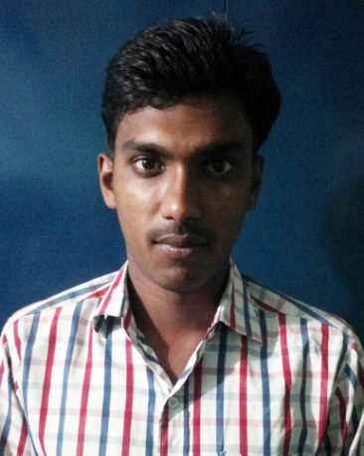**CURRICULUM – VITAE**

**Present Adress**

At-Telenga Bazaar,

Po- Telenga bazaar,

Dist-Cuttack

Email-Priyabrata978@gmail.com

Ph no-7894434827

**Priyabrata Das**

**Carrier Objective:**

* I want to work hard and being a part of organization that gives me challenges and opportunity to learn and update my knowledge and skills. To be a part of team dynamically works towards the growth of organization.

**Education Qualification:**

* B.Com Passed from Uttkal University Bhubaneswar.

12th Passed from NSM City college(Cuttack).

10th Passed from Keonjhar High School(Cuttack)

|  |  |  |
| --- | --- | --- |
| **Exam Passed** | **Board/University** | **Year of Passing** |
| B.Com | N.S.M City College, Cuttack | 2015 |
| 12TH | C.H.S.E, Orissa | 2012 |
| 10TH | Board of Secondary Education, Orissa | 2010 |

**Computer Qualification:**

* 1year Computer Course in PGDCA From star multimedia(Cuttack).

**Personal Skill:**

* Efficient & Well mannered.
* Hard working & Energetic.
* Adoptive & Compatible.
* Positive Attitude.

**Personal Details:**

* **Permanent address** : Name**-**Priyabrata Das

C/o – Pritiranjan das

At –Telenga Bazar

Po –Telenga Bazar

Dist – Cuttack

* Father’s name : Pritiranjan das
* Mother’s name : Minakshi Das
* Date of birth : 06/05/1995
* Sex : Male
* Religion : Hindu
* Category : General
* Nationality : Indian
* Marital status : Unmarried
* Language known : English , Hindi & Oriya
* Salary Expected : Negotiable
* Hobbies : Read Newspaper, Listening to music.

**DECLARATION**

* I hereby declare that all information furnished above is true to the best of my knowledge and belief.

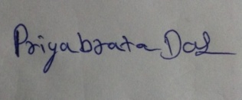

Date: _______

Place: Cuttack **Signature of the applicant**