curriculum vitae

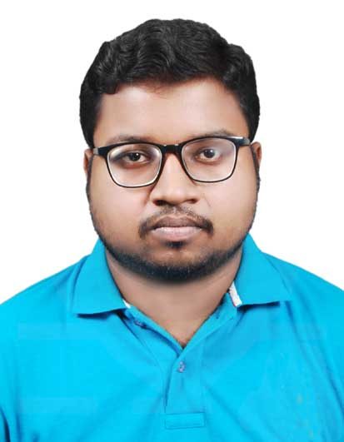

Sashi Bhusan Jena
At-Padhuanpada,Pragati Nagar
Po-Balasore
Balasore ,
Odisha.
E-mail: sashi.bhusan20@gmail.com
Mobile: +91- 8249936253

Career Objective
To hold an innovative, responsible and challenging position in an organization that will enable to utilize and develop my analytical and technical skills and give me an opportunity to Grow with time and build a successful career in an industry.
Personal Skills
- Dedicated individual with strong sense of responsibility
- Flexibility to work in any environment
- Good communication and interpersonal skills.
- Quick learner and Have the capability to grasp new things very easily.
Academic Background
Degree | University / Board | Field of Study | Passing year | Percentage (%)
Matric | CBSE,NEW DELHI | Matric | 2012 | 74.10%
Intermediate | CBSE,NEW DELHI | Commerce | 2015 | 64.20%
Graduation | F.M University | B.A  (English Hons) | 2019 | 48.29%
Professional Qualification
- PGDCA

PERSONAL DETAILS:
- Name : SASHI BHUSAN JENA
- Fathers Name : DILLIP KUMAR JENA
- Date of Birth : 12th May 1996
- Marital Status : Unmarried
- Sex : Male
- Nationality : Indian
- Language : English,Hindi,Oriya

Declaration:

I here by declare that the details furnished above are true to the best of my knowledge.

Date : Place : Balasore Sashi Bhusan Jena

